Explore the Great Outdoors

Spending even a few moments outside daily can significantly improve your physical health by reducing muscle tension, regulating sleep and improving your work performance. Experiencing the outdoors—specifically, green spaces—can also provide some mental health benefits, including reduced anxiety and depression symptoms, decreased stress levels and improved overall mood.

It may seem difficult to incorporate fresh air into your daily routine, so here are a few tips to spend more time in the great outdoors this summer:

* **Find time throughout the day to be outside.** Try to walk or do a similar activity before or after your workday. Alternatively, enjoy lunch outside instead of eating at your desk during the workweek. If working remotely, you could join virtual meetings outside in a quiet place with little background noise or try “walking meetings” with teammates. Focus on finding small ways to incorporate fresh air into each day.
* **Move your workout outside.** If you usually run on the treadmill, consider jogging around your neighborhood instead. Additionally, doing bodyweight or free weight exercises in your backyard or at a park can give you the same workout you would get in the gym but allow you to spend more time outside.
* **Focus on the quality—not quantity—of your time outdoors.** While outside, try to really listen to and look at what’s around you. Are there birds chirping? What color are the flowers? An intentional presence outdoors can help you feel more connected to nature and increase the benefits you receive from the fresh air.
* **Find someone to explore with.** It can be much easier to start a new habit when you have someone to do it with. As such, consider getting together with a partner or a group of friends to participate in outdoor activities.
* **Bring nature indoors.** Even when you can’t get outside for very long, you can still bring little pieces of the outdoors into your home. Think about purchasing a few house plants to place around your home or starting an indoor herb garden.

Spending time outdoors can improve your physical and mental health, so take advantage of the longer summer days and get outside.

EWG Releases Its Dirty Dozen List

The Environmental Working Group (EWG) reports that 75% of all conventional fresh produce sampled this year had residue of potentially harmful pesticides. The “[Dirty Dozen](https://www.ewg.org/foodnews/dirty-dozen.php)” items contain 95% of samples with pesticides. Each year, the EWG releases its Dirty Dozen report ranking pesticide residue levels based on samples taken by federal agencies. The EWG also compiles a “[Clean Fifteen](https://www.ewg.org/foodnews/clean-fifteen.php)” list, with avocados and sweet corn leading the list.

Whether organic or not, all properly handled fresh produce is considered safe to eat, so don’t let the Dirty Dozen scare you away. Do your best to get your daily dose of healthy fruits and vegetables while still being an informed shopper. If you’re still uneasy about pesticides after scrubbing your produce, frozen or canned versions can be a great alternative. Ultimately, it comes down to finding what works best for your household and budget.

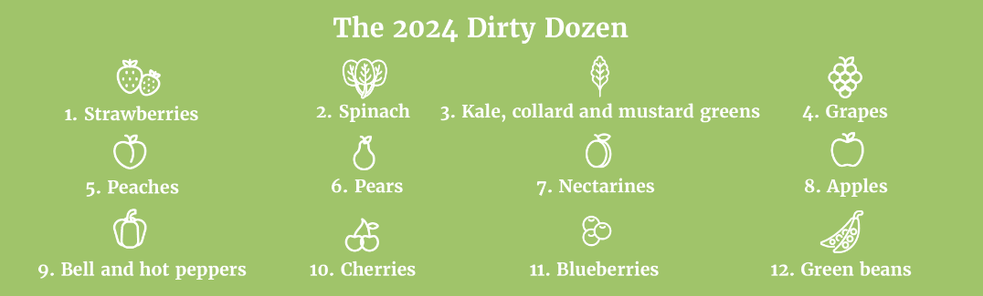

Study Finds That Women Get More Benefits From Exercise Than Men

New study findings from the Centers for Disease Control and Prevention confirm that regular physical activity can prolong life and lower the risk of death. However, they also revealed that women experience greater benefits from exercise than men at lower amounts.

Researchers found that while men were more likely to engage in physical activity than women, women who did so had a 24% lower risk of dying from any cause compared to inactive women. Physically active men had only a 15% lower risk than their inactive counterparts. Furthermore, the most beneficial amount of moderate-to-vigorous physical activity (e.g., brisk walking and cycling) was around five hours per week, though there were also benefits for women starting at just half that weekly amount. Women also saw a more significant reduction in mortality risk when incorporating muscle-strengthening activities (e.g., weightlifting) than men did.

Always talk to your doctor before starting an exercise regimen.

*Makes: 8 servings*

**Ingredients**

½ cup corn (fresh or frozen)

15 oz. can low-sodium black beans (drained and rinsed)

1 cup tomatoes (diced)

½ cup yellow or red onion (diced)

½ cup green pepper (diced)

2 Tbsp. lime juice

2 garlic cloves (finely chopped)

½ cup picante sauce

**Preparations**

1. Combine all ingredients in a large bowl. Chill until serving time.
2. Drain before serving.
3. Serve with low-fat baked tortilla chips or fresh vegetables.

**Nutritional Information  
(per serving)**

Total calories 73

Total fat 0 g

Protein 4 g

Sodium 202 mg

Carbohydrate 14 g

Dietary fiber 5 g

Saturated fat 0 g

Total sugars 3 g

*Source: MyPlate*